CERTIFICATE OF CONFORMITY TO OEM REFERENCE

Juratek Product Reference | MER109
Product Description | Brake Disc
OE Part Number | 9424210912,9424211012,9424211112,9424211212,9424212112,9424230012
Application(s): | Mercedes Actros, Atego, Axor, Econic, Powerline
Application(s): | Mercedes Bus Cirato, Cito, Integro, Touro, Tourino, Tourismo, Travego
Supplier Quality Approval | BS EN ISO9001: 2008

We certify that the goods detailed above conform to the material & dimensional specifications required by Juratek Ltd and that they are fit for direct OEM replacement.

Print Name: | Andrew Kibler
Signed: | 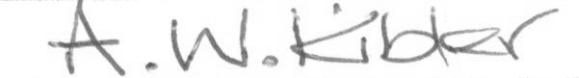
Position: | Quality & Engineering Manager
Date: | 31 July 2026

